Jenkins Approval Pipeline
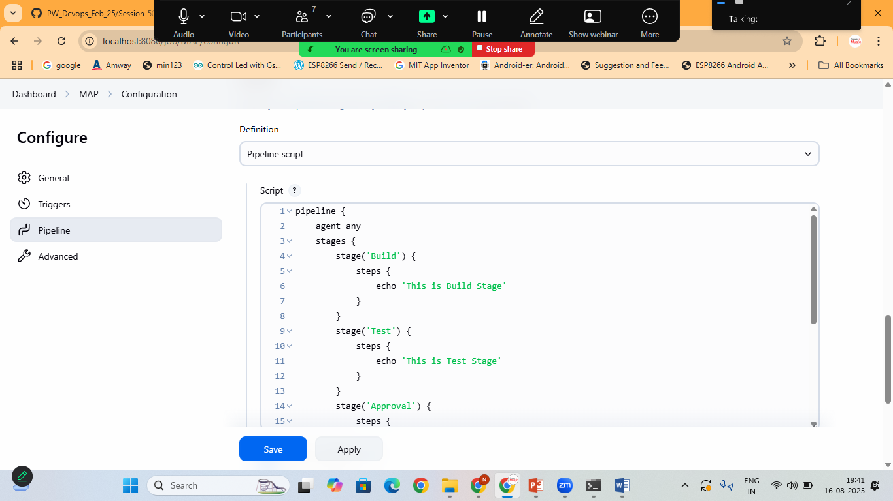
Pipeline:
pipeline {
agent any
stages {
stage('Build') {
steps {
echo 'This is Build Stage'
}
}
stage('Test') {
steps {
echo 'This is Test Stage'
}
}
stage('Approval') {
steps {
timeout(time:15,unit:"MINUTES"){
input message:'Do You Want To Approve The Deployment?', ok:'yes'
}
}
}
stage('Deployment') {
steps {
echo 'App Deployed'
}
}
}
}

Email Approval Pipeline
Make sure Email is properly configured in Jenkins
Goto>Mange Jenkins> system> E-mail Notifications
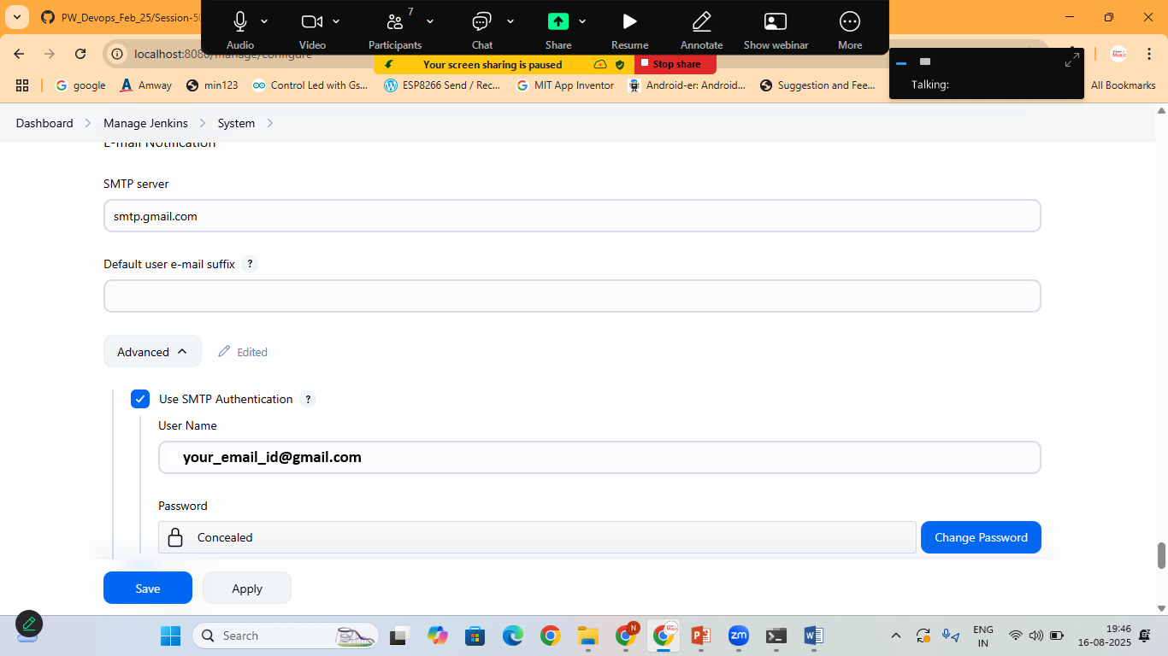
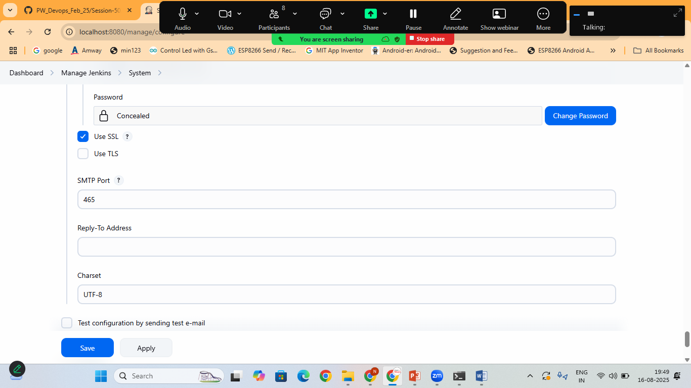

pipeline {
agent any
stages {
stage('Build') {
steps {
echo 'This is Build Stage'
}
}
stage('Test') {
steps {
echo 'This is Test Stage'
}
}
stage('Email for Approval') {
steps {
mail to: 'youremail@gmail.com',
subject: "Approval Needed for Production Deployment",
body: """\
Build #${env.BUILD_NUMBER} is ready for approval.

Click the following link to approve:
${env.BUILD_URL}

Login and click "Proceed" in the "Approval" stage.
"""
}
}
stage('Approval') {
steps {
timeout(time:15,unit:"MINUTES"){
input message:'Do You Want To Approve The Deployment?', ok:'Approve'
}

}
}
stage('Deployment') {
steps {
echo 'App Deployed'
}
}
}
}

